Patient Acceptance Form

Personal Information

Name_______________________Last name_____________________
Address___________________________________________________

Tel. __________________________Mobile. ______________________

E.Mail____________________________________________________

Date of birth_________________ ID number ___________________

Health condition

Yes/No | Do you currently have any pain? (Please mark the place in the form provided) | 1
Yes/No | Do you now have an illness or health disorder - physical or mental? | 2
Yes/No | Are you taking medication? | 3
Yes/No | Are you in medical care? | 4
Yes/No | Have you had any surgery in the last six months? | 5
Yes/No | Has your body been damaged by an accident, illness or any other reason in the past? | 6
Yes/No | Do you suffer from any allergies (to any oils)? | 7
Yes/No | Have you had a stroke in the past? | 8
Yes/No | Have you had cancer in the past? | 9
Yes/No | Is there anything you are not asked about and would like to add? | 10
Yes/No | Are you pregnant? month: | 11
Yes/No | Are you breastfeeding? | 12
Yes/No | Are you menstruating? | 13

If you've answered yes to any of the questions, please fill out a medical questionnaire.

Declaration

I confirm that I am aware that the treatment requested by me is not a substitute for any treatment in conventional medicine and / or any consultation with a conventional doctor, and that I do not intend to discontinue any medication without consulting a doctor.
I confirm that my answers to all the questions are complete and honest and that I did not lack any information.

___________________ ___________________
Signature Date

Name _______________________ Date __________

Mark the location of the pain

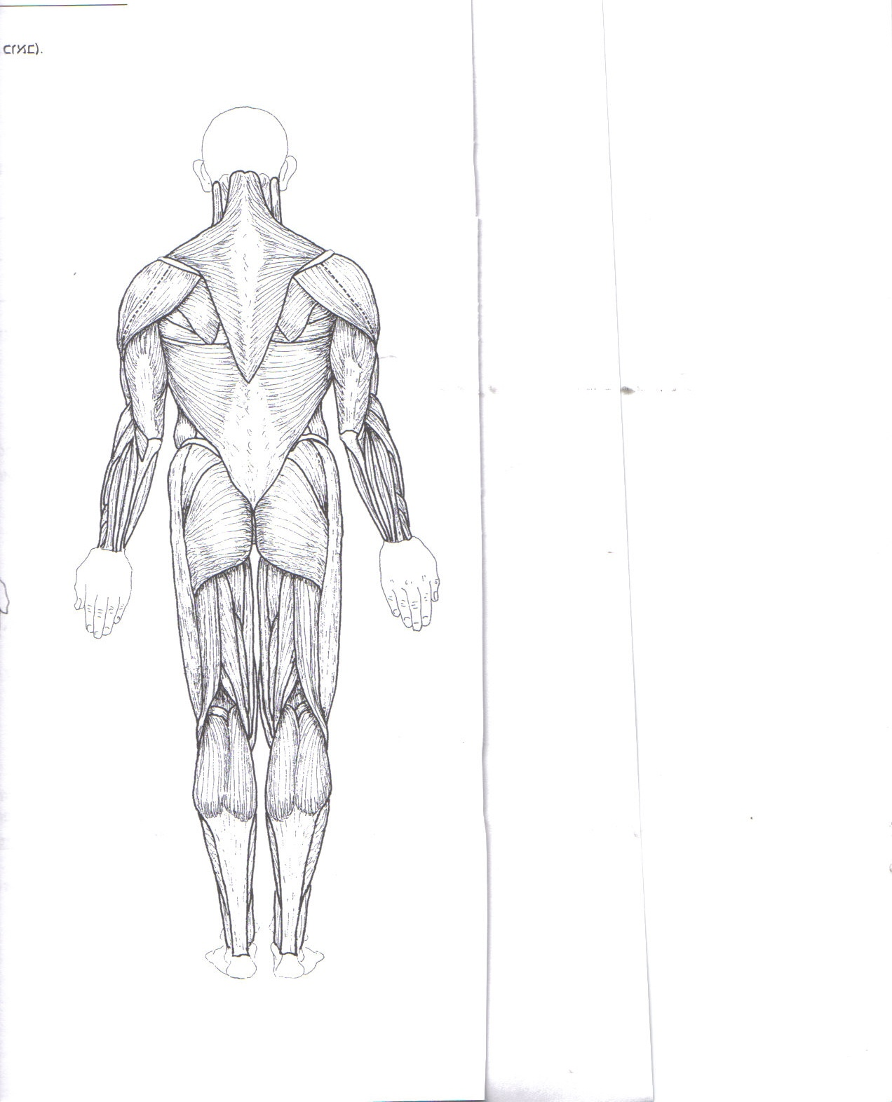
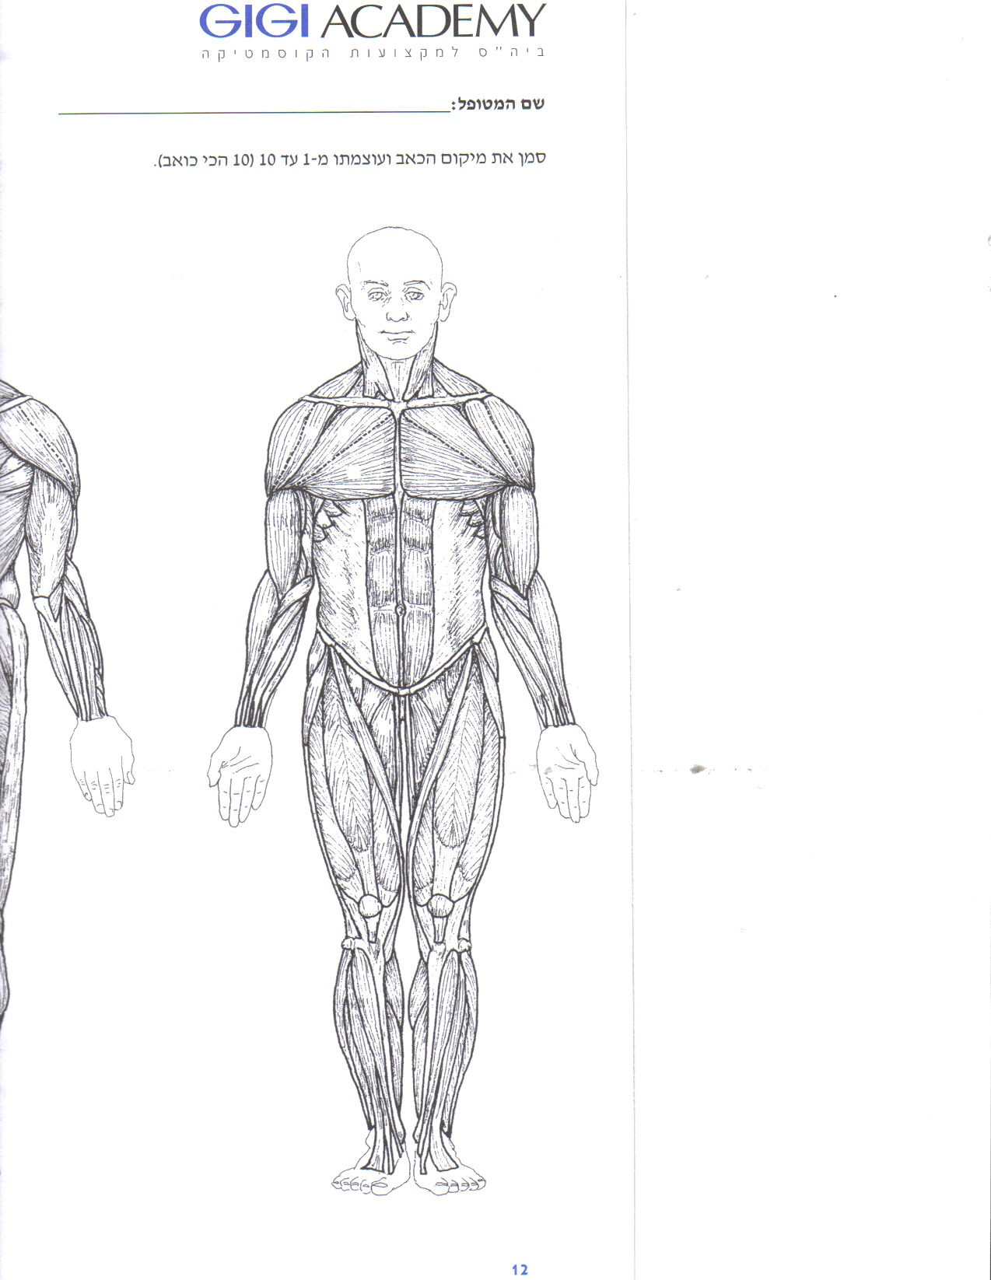

Rate the intensity of the pain

1 – 2 – 3 – 4 – 5 – 6 – 7 – 8 – 9 – 10

Health questionnaire

The patient's information appearing in this questionnaire is confidential. The information in this questionnaire will be used by the therapist solely in order to best treat the patient and in a way that supports his / her needs and goals.

Part C - Details of the state of health

If you've answered one of the questions in the affirmative, please specify.

______________________________________________________________________________Details:

____________________________________________________________________________________________________________________________________________________________________________________________________________________________________________________________________________________________________________________________________________________________________________________________________________________________________________________________________________________________________________________________________________________________________________________________________________________________________________________________________________________________________________________________________________________________________________________
____________________________________________________________________________________________________________________________________________________________________________________________________________________________________________________________________________________________________________________________________________________________________________________________________________________________________
_________________________________________________________________________________________________________________________________________________________________________________________________________________________________________________________________________________________________________________________________________________________________________________________________________________________________________

Declaration

I confirm that I am aware that the treatment requested by me is not a substitute for any treatment in conventional medicine and / or any consultation with a conventional doctor, and that I do not intend to discontinue any drug treatment without consulting a doctor.
I confirm that my answers to all the questions are complete and honest and that I did not lack any information.

____________________ ______________________
Signature Date

Patient's name ______________________________
Observation/Remark:
___________________________________________________________________________________
___________________________________________________________________________________
____________________________________________________________________________________
____________________________________________________________________________________
Documentation of treatments:
_____________________________________________________________________________________
_____________________________________________________________________________________
_____________________________________________________________________________________
_____________________________________________________________________________________
_____________________________________________________________________________________
_____________________________________________________________________________________
_____________________________________________________________________________________
_____________________________________________________________________________________
_____________________________________________________________________________________
_____________________________________________________________________________________
_____________________________________________________________________________________
_____________________________________________________________________________________
_____________________________________________________________________________________
_____________________________________________________________________________________
_____________________________________________________________________________________
_____________________________________________________________________________________
_____________________________________________________________________________________
_____________________________________________________________________________________
_____________________________________________________________________________________
_____________________________________________________________________________________
_____________________________________________________________________________________
_____________________________________________________________________________________
_____________________________________________________________________________________
_____________________________________________________________________________________

